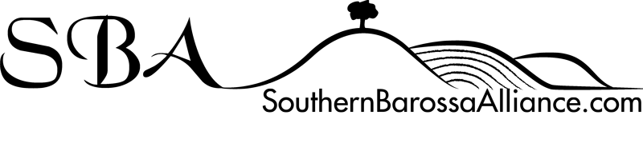

Southern Barossa Alliance Inc

Financial Management Policy

Version | Date | Prepared by: | Approved by:
Draft | 9/10/2017 | ST/ZP/M-lL
One | 6/11/2017 | SB

INTRODUCTION
The Southern Barossa Alliance (SBA) is entrusted to manage its own funds as well as funds on behalf of community groups with which it has signed Memoranda of Understanding. It is critical that this is undertaken with transparency employing sound financial processes with appropriate checks and balances. By undertaking this role, the SBA will make access to funds easier for member groups and remove administration burden from The Barossa Council (TBC).

PURPOSE
All financial transactions undertaken by SBA must comply with this policy and follow the procedures in this document.

SCOPE
This policy applies to all SBA Committee members, staff and volunteers, and any other personnel who may be doing work for SBA.

DEFINITIONS
‘Petty Cash’ is held by a member organization and used for transactions of less than $50.
‘Member Group’ is a community organization which has signed an MOU with SBA.
‘SBA Approved Person’ is the SBA Treasurer, or an approved SBA Committee Member.

POLCIES
- The SBA Approved Person, will maintain a financial management system which clearly identifies which member group owns all relevant funds managed by the SBA.
- Funds may only be used by the member group which owns them.
- The SBA may recoup fees and charges incurred in related transactions from the member groups.
- Allocation of interest earned or charges to member groups will be based on the % of total funds held by SBA for the group at 1 July of the current year or another method mutually agreed by all parties. An example of where this could be required is for insurance policies taken out to cover all member groups.
- At least 2 signatures required for all financial transactions. All financial transactions must be documented and approved/signed by at least one, pre-approved, member/s of the member group before being accepted and approved by SBA Approved Person, and then processed through the accounts held by SBA.
- Subject to the appropriate authorization/s from the member groups SBA Approved Person, may provide the member groups with funds to employ as petty cash subject to the following limitations:
  - The maximum value of a single petty cash transaction is $50;
  - A receipt for the petty cash distributed by the member groups must be written and a copy forwarded to the SBA treasurer; and
  - Larger transactions may not be split to form several transactions each below the petty cash limit
- A financial report shall be given to each member group at intervals agreed in the MOUs but not exceeding 12 months
- Audited accounts for the SBA and all member groups will be presented at the SBA AGM.

ROLES & RESPONSIBILITIES
The Treasurer, or an approved SBA Committee Member, is responsible for:
- Maintaining the SBA Financial management system and keep transaction records compliant with this policy;
- Recommending the appointment of an independent auditor at the AGM to audit the accounts for presentation at the SBA AGM;
- Providing a financial statement for each member group at all SBA Executive meetings and at member group meetings at intervals compliant with this policy;
- Promptly depositing all monies received by the SBA;
- Issuing petty cash as requested to member groups compliant with this policy
- Maintaining the list of parties authorised to undertake financial transactions for all member groups
All SBA members, and staff, are responsible for:
- Promptly forwarding all monies received to the SBA Approved Person.

