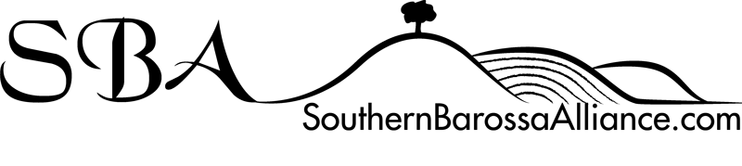
Love the place you live

With renewed energy and focus, the Southern Barossa Alliance is working towards a cohesive and vibrant community alongside residents, businesses, Clubs and Volunteer Groups.
We are seeking community and business participation to promote increased economic activity, business development, community development and the upgrading of tourism facilities.
We have an enviable country lifestyle and economic potential so we believe the Southern Barossa will be a great place to live, work and visit well into the future.
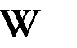
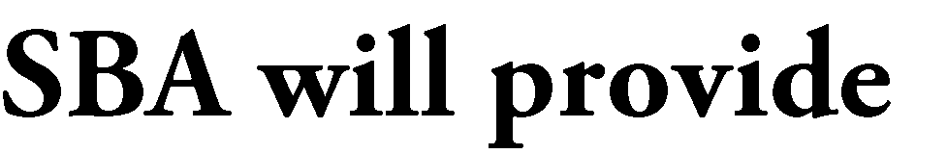

- Provide a forum for discussion on concerns, grievances and business development opportunities and can then take on an advocacy role when dealing with local community members or organisations and council.
- Provide input on business development and impacts on businesses into the Barossa Council regional and town planning processes such as the Community Plan, Community and Economic Development Forum and Sport, Recreation and Community Asset Forum and the . We are currently actively pursuing the sealing of Lyndoch Road, with the provision of increased signage, for southern entrances to the Barossa Valley.
- Promote increased business retail and promotion opportunities by organising events such as the Tour Down Under, Gourmet Weekend on the Village Green, the Barossa Vintage Festival, Southern Barossa regional wine releases and other festivals/community events.
- As an incorporated body, pursue grants to promote business and industry development and innovation in the Southern Barossa. We have a close association and working relationship with Regional Development Australia, Barossa.
- Promote tourism initiatives either independently or through our close working relationship with Tourism Barossa. We are currently working on developing a Southern Barossa Tourism Map with their support. This map will include public tourist sites as well as members services, food, wine and accommodation sites.
- Provide a page for our Business members on the SBA website as well as inclusion in the site directory. Our aim is for the SBA website to become the lead Community and Business website for the Southern Barossa.

Contact Deputy Chair, Steve Balch on 0417 858 758 or membership officer, Gwyn Balch 0417 853 080

